| **Test Name** | | Choose a Category | | | |
| --- | --- | --- | --- | --- | --- |
| **Use Case Tested:** | | Play a Game-New Game | | | |
| **Test Description:** | | To test whether players can choose a category at the start of game play | | | |
| **Pre-conditions** | | User must have logged in | | | |
| **Post-conditions** | | The player is able to choose and play a game in the category they have chosen | | | |
| **Notes:** | |  | | | |
| **Result (Pass/Fail/Warning/Incomplete)** | |  | | | |
|  | **TEST STEP** | | **EXPECTED TEST RESULTS** | P | F |
|  | User will click the new game button on the open game screen | | The user should be presented with a popup drop down menu consisting of a list of the categories available | P |  |
|  | User will choose a category by clicking their choose | | User should be able to select a category and then have the game start | P |  |

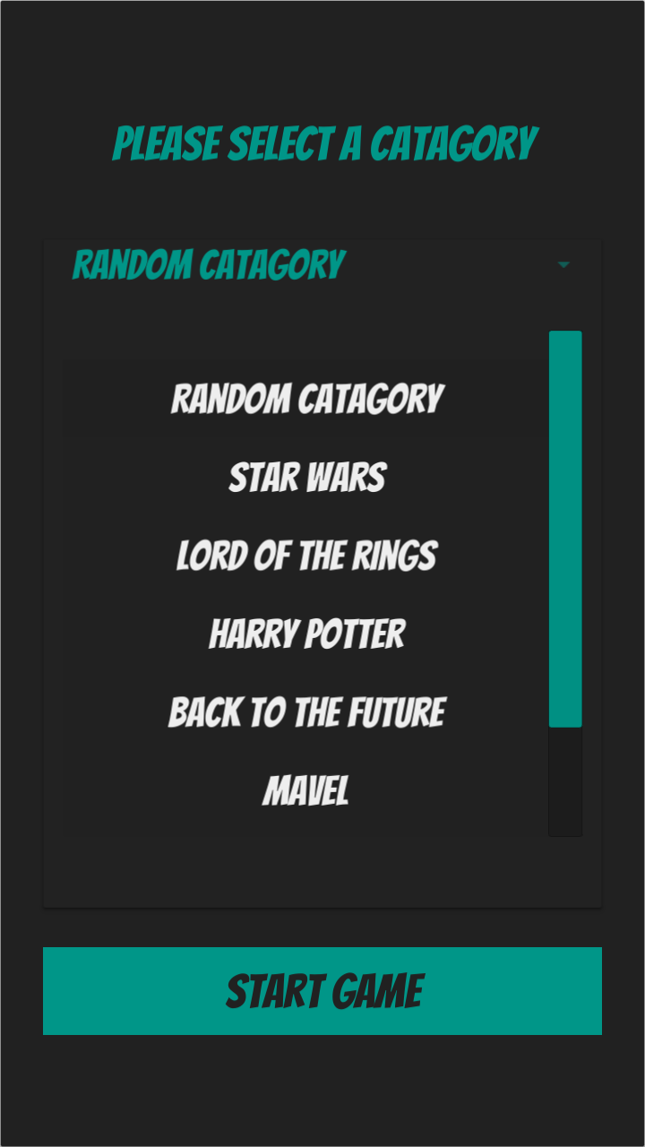

| **Test Name** | | Continue a game with a preselected catagory | | | |
| --- | --- | --- | --- | --- | --- |
| **Use Case Tested:** | | Play a Game-New Game | | | |
| **Test Description:** | | To test whether players can continue a game where the category is already selected | | | |
| **Pre-conditions** | | User must have logged in  There must be an ongoing game in need of an opponent | | | |
| **Post-conditions** | | The player is told the category and can then play a round | | | |
| **Notes:** | |  | | | |
| **Result (Pass/Fail/Warning/Incomplete)** | |  | | | |
|  | **TEST STEP** | | **EXPECTED TEST RESULTS** | P | F |
|  | User will click the new game button on the open game screen | | The user should be presented with a popup telling them what category the round will be | P |  |
|  | User can select start game | | The round will start | P |  |

